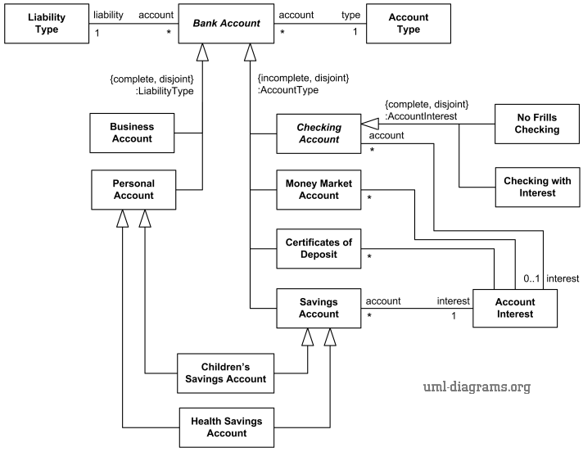

***Bank account taxonomy UML class diagram example with generalization sets and power types.***

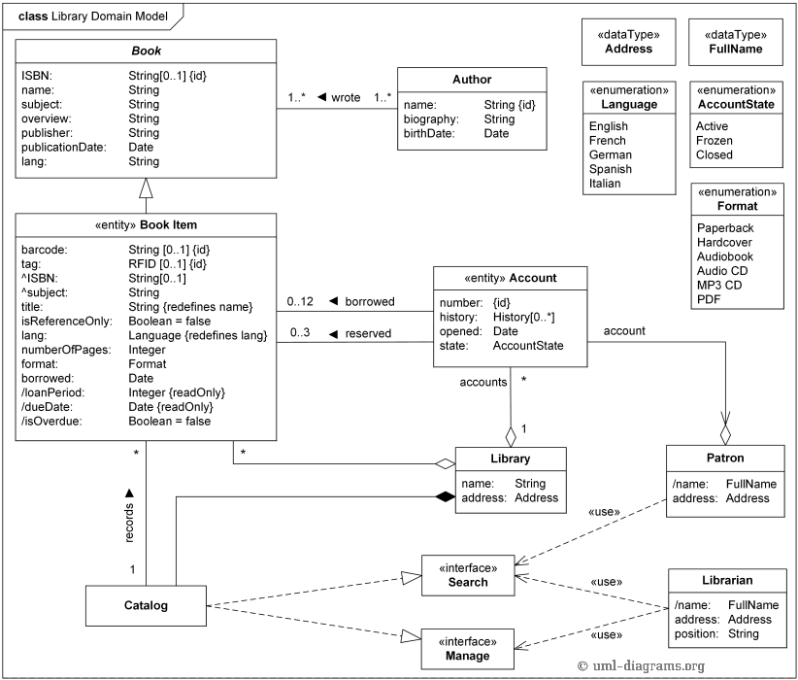

***UML class diagram example of the Library Domain Model.***

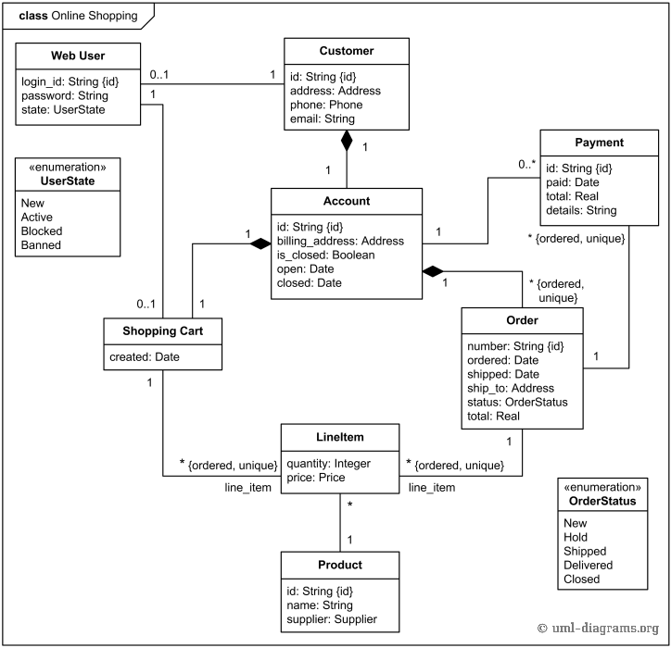

***Online shopping domain UML class diagram example.***

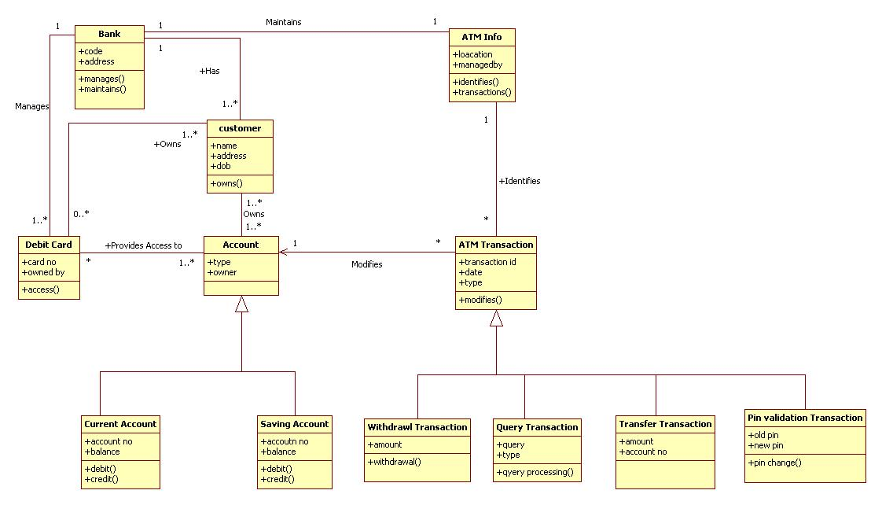

***UML Diagram for ATM Machine***

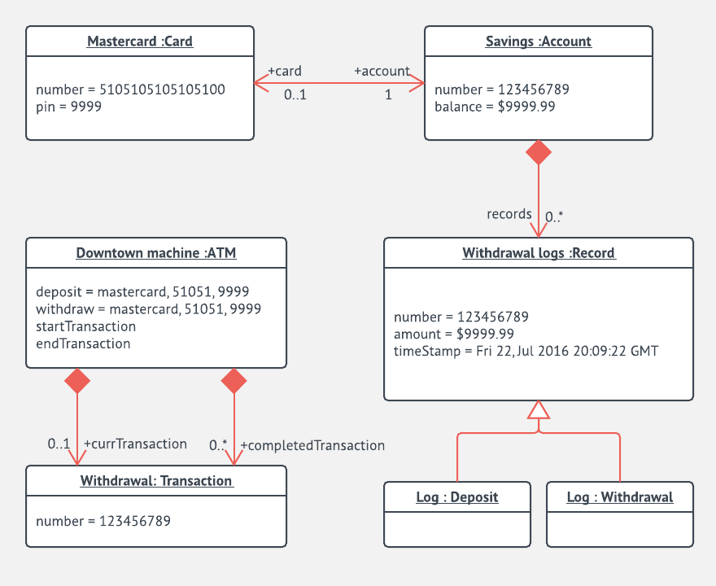

***UML Object Diagram for ATM***

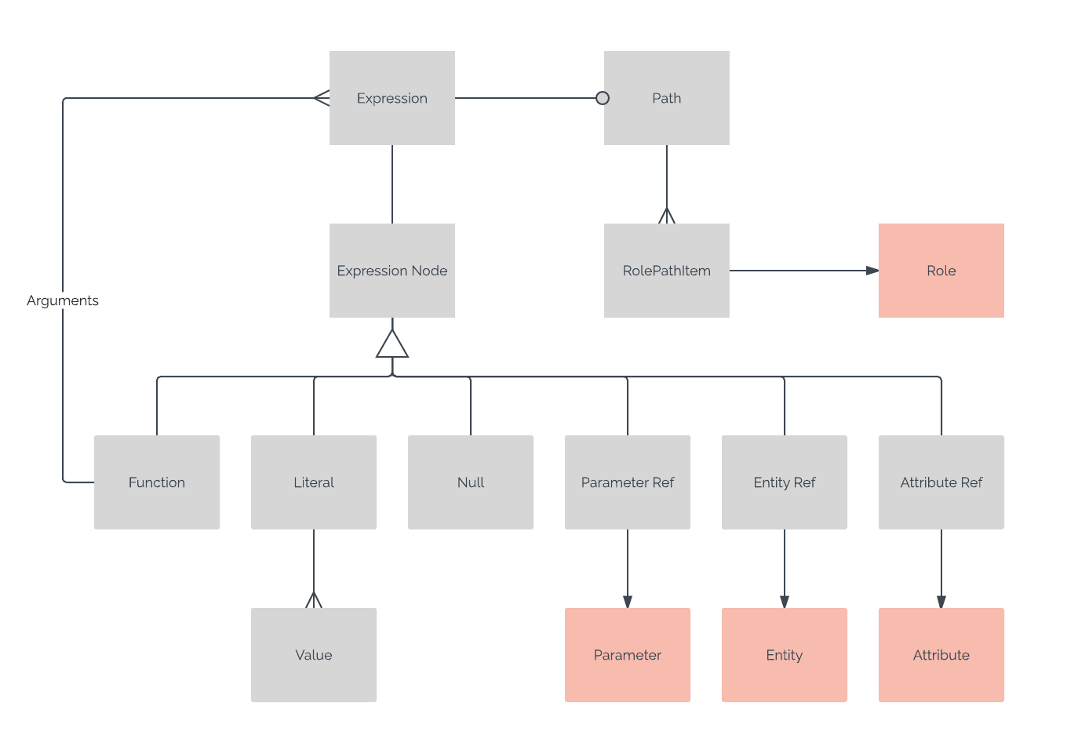

***UML Object Diagram for Relationships***

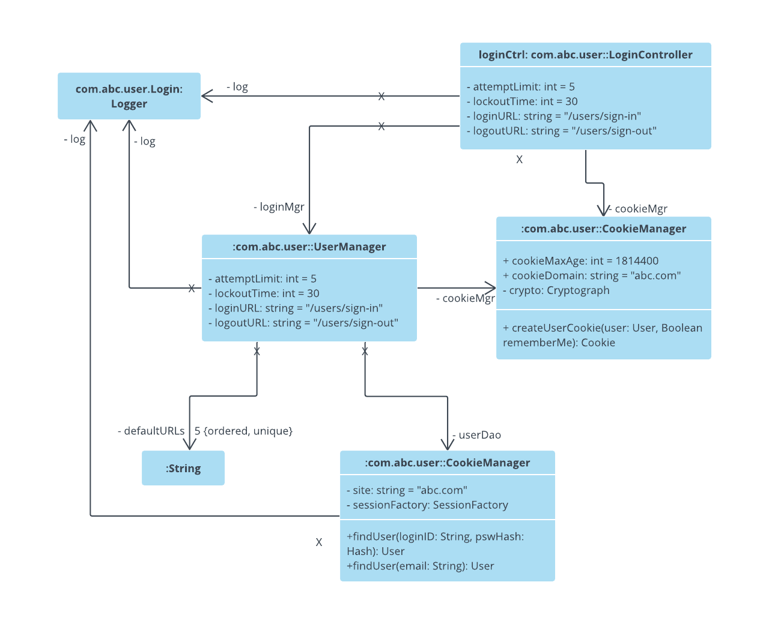

***UML Object Diagram for Login***